Feedback on Skill Development British Council English Language Course
Dated: 15-07-2021
A Google meet was organized by Dr. Renuka Thapliyal, the college coordinator of English Language course offered by British Council, and Prof. Richa Ahluwalia, the course facilitator, for taking feedback of students after the completion of course. They were also circulated Google form for filling up of feedback. Students shared their experiences on following points:
- How has this course enhanced their knowledge of English?
- Does this course improve their chances of getting employment?
- Has this course helped in improving their pronunciation, accent and intonation?
- Has this course mitigated their fear of English language?
- If given a chance would they join such courses in future?

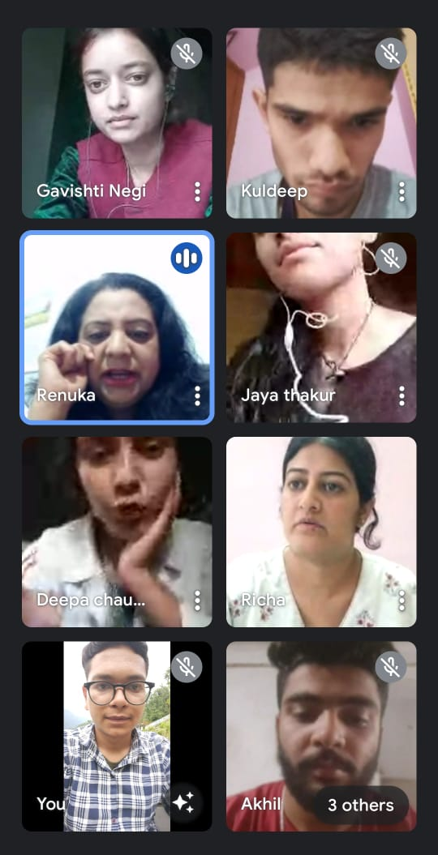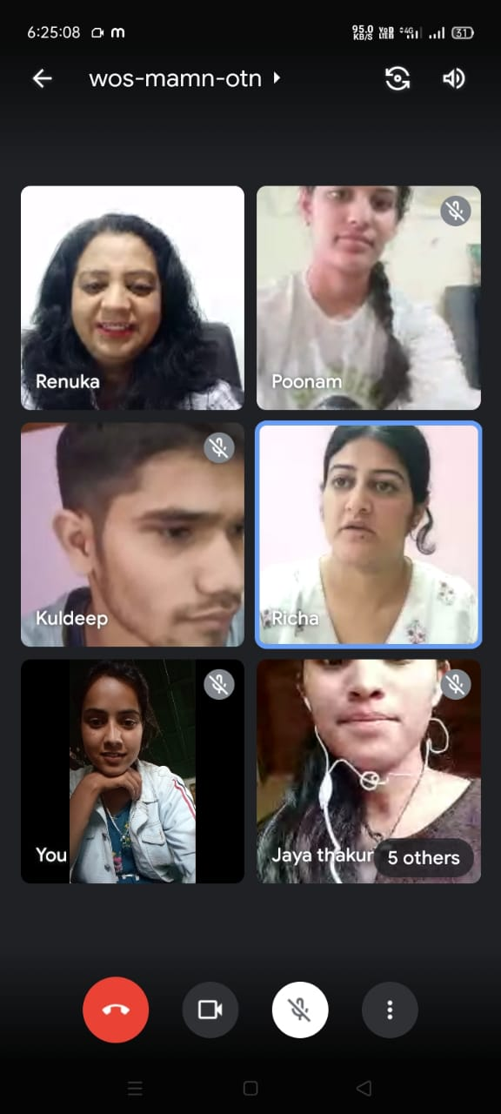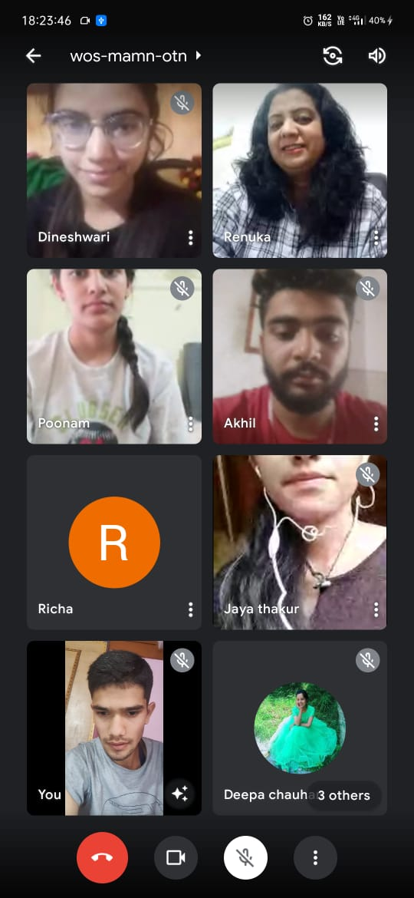

Dr. Renuka Thapliyal Prof. Richa Ahluwalia
College Course coordinator Course Facilitator
English Language Course

